FE630 Portfolio Theory and Applications

Final Project

(Xinhang Wang & Qi Yuan)

December 16, 2018

# 1.Introduction

This project aims to build a factor-based model Long/Short Global Macro Strategy with portfolio, which would maximize the returns with a fixed target Beta or minimize variance with a target return. So, we can understand the behaviors of these strategies during a historical period.

The factor model is based on French-Fama-Three-Factor Model to get securities expected returns and the coefficients can be computed by a regression on the factors using a large set of historical data. Based on real securities data, the portfolio return can be tested by using 2 models: Max Return Model (Time Series Model), and Min Variance with 15% Target Return. After that, basic statistics value of portfolio would be given to analyze the performance of portfolio.

# 2.Data Description

Here we consider totally 13 ETFs, and we select S&P 500 as our benchmark.

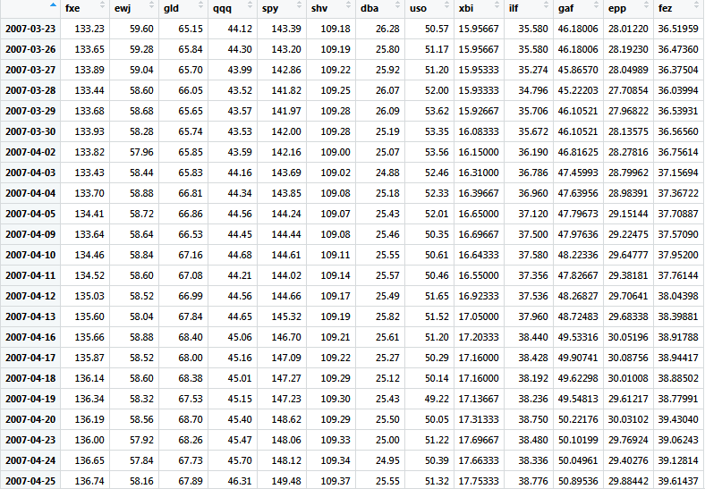

Table 1 ETFs data

Table 1 is a screenshot of ETFs data downloaded from Yahoo Finance. Because part of data are not available during 2008, so we choose the period from 03/23/2007 to 07/24/2017. The whole period would be divided into 3 different parts:

1. Before the crisis: 03/23/2007-03/10/2008
2. During the crisis: 03/11/2008-06/30/2009
3. After the crisis: 07/01/2009-07/24/2017

Also, the different estimator: Short Term (10 days), Middle Term (75 days), and Long Term (150 days) would be used to estimate the 3 coefficients of the factor model.

# 3.Estimator Model

3.1 The French-Fama -Three- Factor Model

Our factor model is the French-Fama -3-Factor model and the data are downloaded from <http://mba.tuck.dartmouth.edu/pages/faculty/ken.french/data_library.html>.

The French-Fama -Three- Factor Model is an asset pricing model that expands on the Capital Asset Pricing Model (CAPM) by adding size and value factors to the market risk factor in CAPM. The three factors are market risk, the outperformance of small versus big companies and the outperformance of high book/market versus small book/market companies. In our project, we use this model to estimate the mean return and covariance matrix of the selected securities.

The formula is expressed as



The three coefficients , ,as well as the intercept are computed by a regression of the time series  against the time series ,  and  . In our project, we use long-term time series data of 200 days, mid-term of 100 days and short-term of 50 days to do the regression, respectively. And represents small size variables minus big one, and  represents high minus low in book value to market ratio.

3.2 Time Series Model (Max Return with Target Beta)

Time Series Model is used to construct portfolio to maximum portfolio expected return with a target return. The optimization of portfolio can be presented as the form from Investment Strategy



where

1. Q is the Identity matrix (with diagonal elements equal to 1), is the composition of a reference Portfolio (the previous Portfolio for backtesting, otherwise has all its components equal to 1/n) and  is a small regularization parameter to limit the turnover (alternative: Q = , the covariance matrix);
2.  is the Beta of security  as defined in the CAPM Model so that is the Beta of the Portfolio;
3.  is the Portfolio's Target Beta, we use  as our target beta

3.3 Min Variance with 15% Target Return

As a consequence of the previous section, the benchmark problem designed as min-variance with a 15% annual return target is to be formulated as follows:



where  is the covariance matrix, and Under that factor model, the return of a security is given by the formula

Specially, in Investment Strategy, with , it can be

, and .

3.4 Implementing Method

For the optimization process, we apply ‘solve.QP’ function in ‘quadprog’ package in R in this project. The detail about this function is shown below.

=

# 4.Performance and Risk Report

4.1 The return of portfolios under three different periods with beta of 0.5,1,1.5

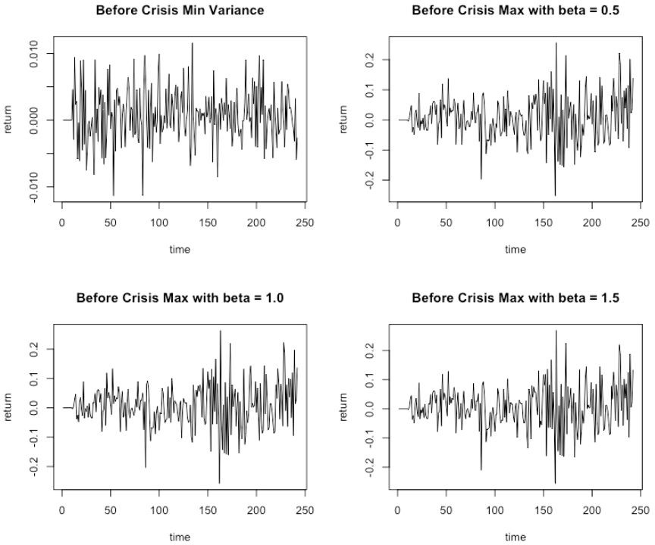

Figure 1 The return of portfolio before crisis

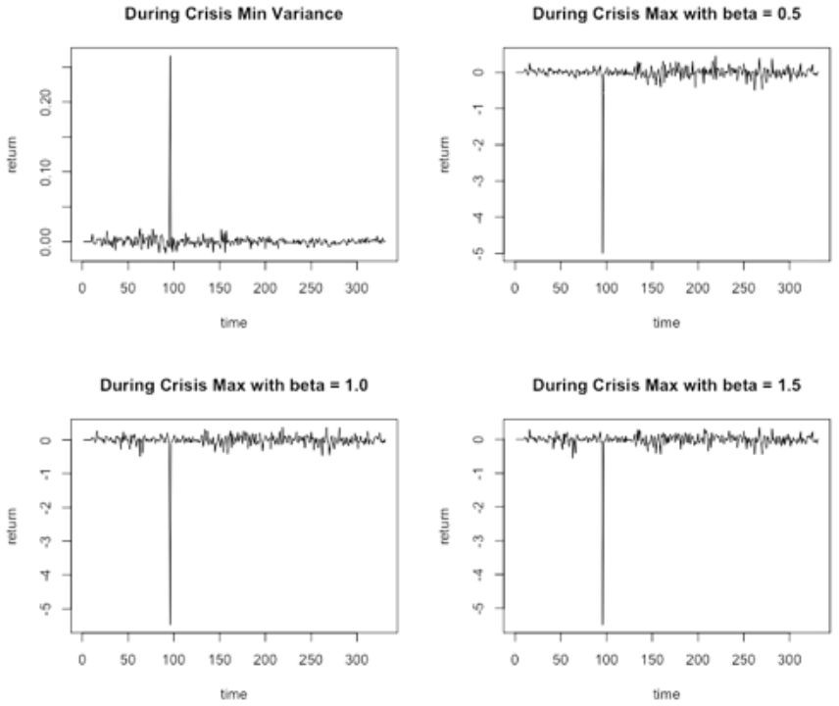

Figure 2 The return of portfolio during crisis

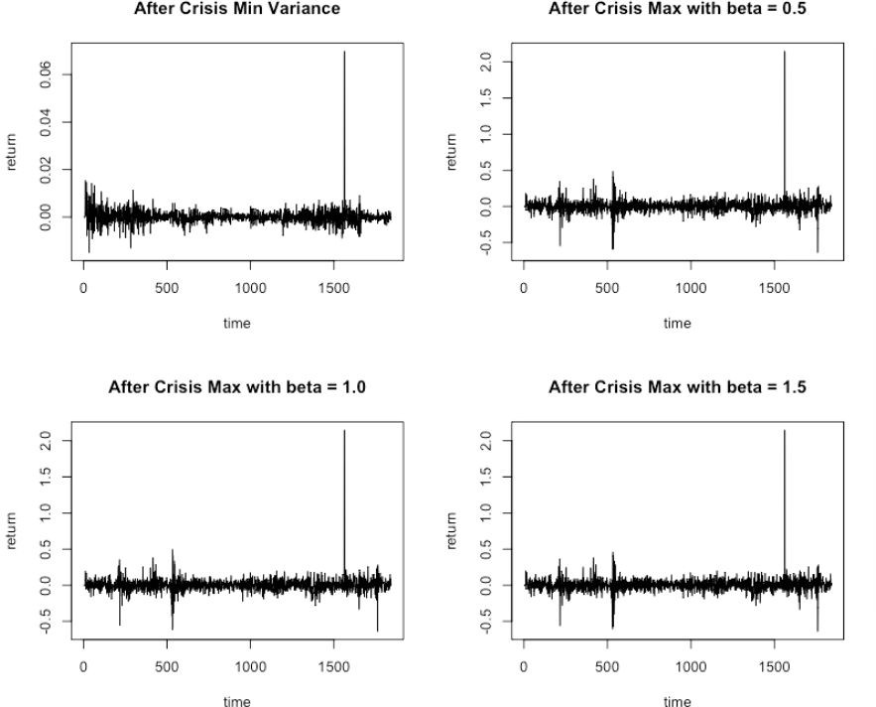

Figure 3 The return of portfolio after crisis

By comparing the return of portfolio in three different periods, we can find that there is one extreme return with relatively large and absolute value during the crisis. While after the crisis, the return would go back to the normal standard level at that time, which is violating around zero.

4.2 Density distribution analysis

Here, we will pick up the return series of max model with target beta = 0.5 as an example.

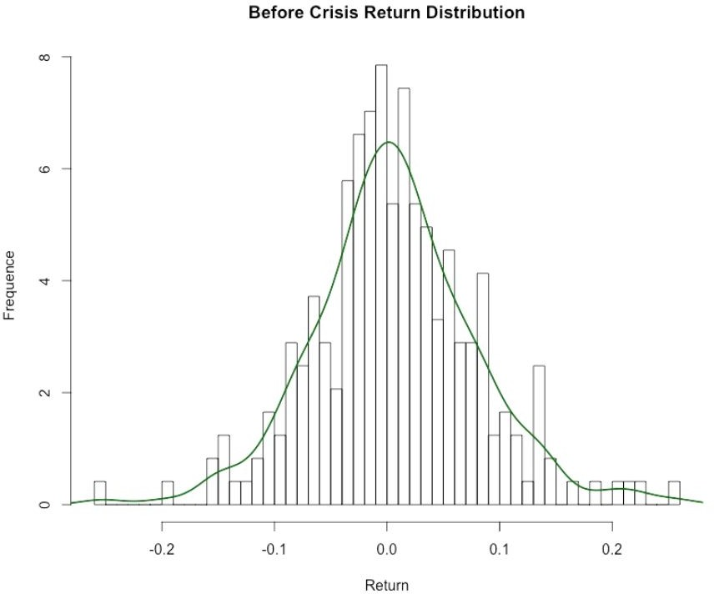

Figure 4 Return Distribution Before Crisis

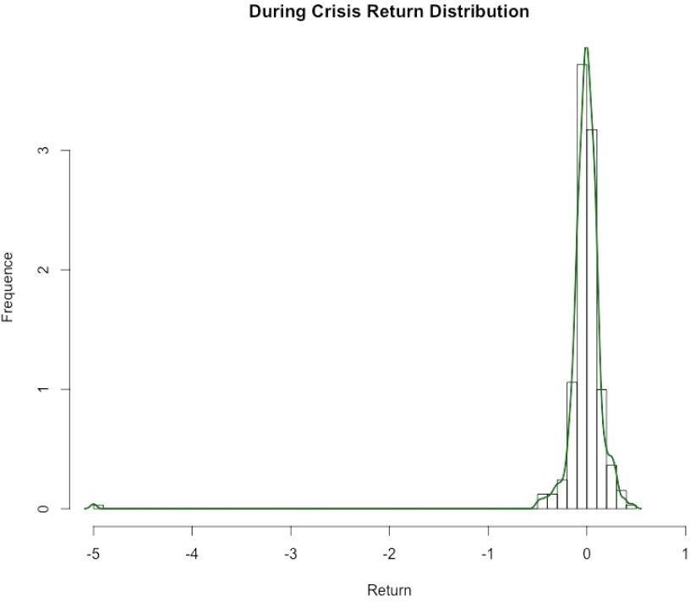

Figure 5 Return Distribution During Crisis

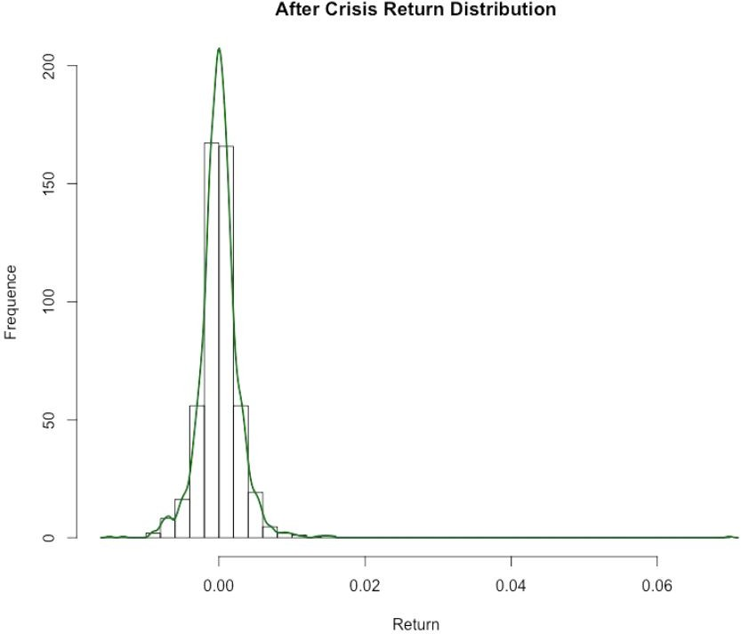

Figure 6 Return Distribution After Crisis



From the plots above, it can be clearly seen that before the crisis, the distribution of return is similar to a Normal Distribution with mean equaling around to zero.

However, when crisis broke out, the distribution during crisis is changed to be left-skewed with mean return nearly zero, which means it has a negative skewness. And after that it will shift to right skewed distribution with mean zero.

4.3 Comparison of cumulative returns

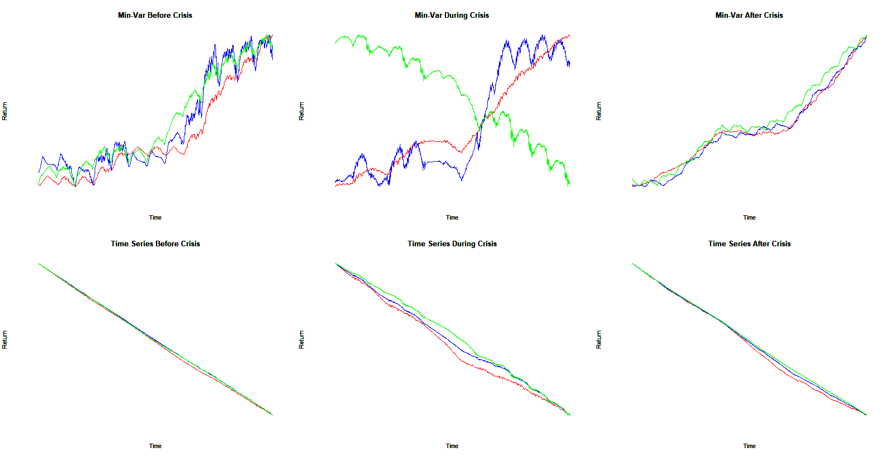

Figure 7 Cumulative Return in Different Period with beta = 0.5

(red line: short; blue line: mid; green line: long)

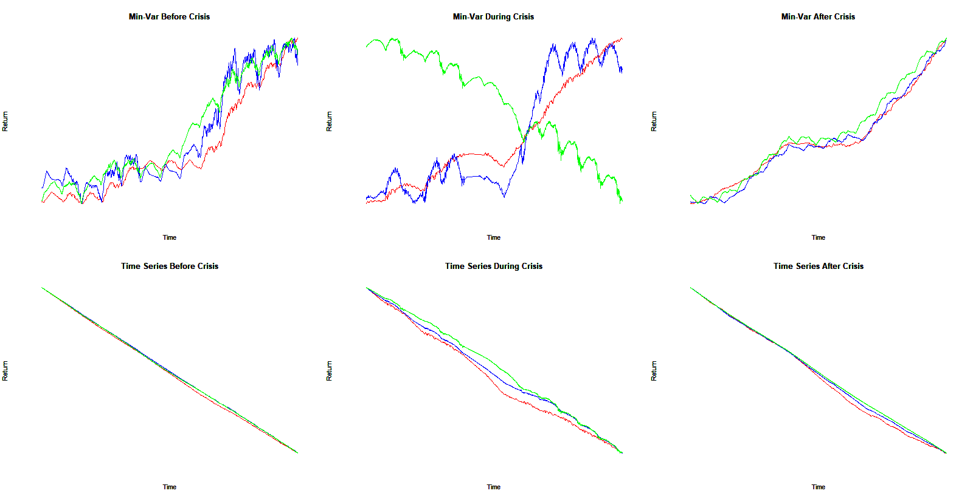

Figure 8 Cumulative Return in Different Period with beta = 1



Figure 9 Cumulative Return in Different Period with beta = 1.5

We can find that the plots of different target beta are quite similar.

4.4 Statistical analysis

For better comparing 13 indexes, key statistics are computed for ETF. Below is the table presents a summary of different factors during the whole time period.

|  |
| --- |
|  |
| Table 2 key statistics for ETF’s investment universe from 2007-2008 |

Below are tables for key factors under different time periods:

|  |
| --- |
| 6 |
| Table 3 Before the crisis, LT |
| 4 |
| Table 4 During the crisis, LT |
| 8 |
| Table 5 After the crisis, LT |

Below are tables presenting investment portfolios with different rebalancing period during various time periods. We take the rebalancing period of 10-day, 75-day, and 150-day into consideration.

1. 10-day period:

|  |
| --- |
|  |
| Table 6 key statistics for investment and benchmark portfolio with 10 day period |
|  |
| Table 7 10-day statistics before the crisis |
|  |
| Table 8 10-day statistics during the crisis |
|  |
| Table 9 10-day statistics after the crisis |

1. 75-day period:

The table presents a summary of the performance of the investment and benchmark portfolio with 75-day rebalancing period under different target beta during the whole chosen period (from 2007-2018). The next three tables show similar contents for three different time period: before financial crisis (2007-2009), during financial crisis (2008-2009), after financial crisis (2009-2017).

|  |
| --- |
|  |
| Table 10 75-day statistics |
|  |
| Table 11 75-day statistics before the crisis  For results before financial crisis, it shows that the volatility of the benchmark is lower than that of the investment portfolio with beta of 1 and 1.5. Thus, the portfolio with a beta of 0.5 is a proper one to choose. |
|  |
| Table 12 75-day statistics during the crisis  For the period during the financial crisis, volatilities of all investment portfolios with different beta seem to be similar and have a better performance compared to that of S&P500. |
|  |
| Table13 75-day statistics after the crisis  After the financial crisis, to choose portfolios with beta of 1 and 1.5 would be appropriate because of a higher return and lower risk, comparing to both the portfolio with a beta of 0.5 and the benchmark one. |

1. 150-day period:

|  |
| --- |
|  |
| Table 14 150-day statistics |
|  |
| Table 15 150-day statistics before the crisis |
|  |
| Table 16 150-day statistics during the crisis |
|  |
| Table 17 150-day statistics after the crisis |

For better analysis, plots for performances of three different portfolios with different rebalancing periods as well as different beta are constructed. We compare the return of S&P500, benchmark portfolio and the Fama-French portfolio.

1. 10-day:

|  |
| --- |
|  |
| Figure 10 10-day daily performance with a beta of 0.5 |
|  |
| Figure 11 10-day daily performance with a beta of 1 |
|  |
| Figure 12 10-day daily performance with a beta of 1.5 |

1. 75-day:

|  |
| --- |
|  |
| Figure 13 75-day daily performance with a beta of 0.5 |
|  |
| Figure 14 75-day daily performance with a beta of 1 |
|  |
| Figure 15 75-day daily performance with a beta of 1.5 |

1. 150-day:

|  |
| --- |
|  |
| Figure 16 150-day daily performance with a beta of 0.5 |
|  |
| Figure 17 150-day daily performance with a beta of 1 |
|  |
| Figure 18 150-day daily performance with a beta of 1.5 |

# Conclusion

1) In this project, two optimization models are built: min-variance model and max return model with target beta based on the French-Fama three factor model, analyzing the performance of different time periods.

1. The analysis of key statistics under three different period gives the conclusion that returns of portfolios could be higher with a relatively high beta, but a high risk exposure occurring simultaneously should also be taken into considered. Besides, with a 75-day period, investment portfolios always get a better result.

3) By analyzing the min-variance of different terms, figures we constructed in this project present that performances of mid and long term portfolios are relatively better that that of the short term portfolio. While comparing different values of beta, it has been found that differences between performances are slight.